**CHAPTER ONE**

**INTRODUCTION**

**1.1 Background of the study**

Over the years, engineers, scientist and ergonomist have extolled the conventional automobile screw jack (scissors jack) as being very efficient, yet continue to seek new designs to increase reliability and reduce its shortcomings and maintenance costs (Okoronkwo & Chaudhary, 2016). Screw application is used in the elevation of vehicles or objects. The operation of the screw jack is such that it comprises a handle for driving a bolt element (lead screw) manually to adjust the height of the jack to elevate a vehicle or an object. Existing jacks are of great disadvantage to elderly women especially under unfavourable weather condition (Benjamin & Modestus, 2017).

The quick lifting jack with gear arrangement for automobiles garages has been developed to later the needs of small and medium automobile garages, who are normally man powered with minimum skilled labours. The design and fabrication of lifting mechanisms play a crucial role in various industries such as automotive, construction, and manufacturing (Rout *et al.,* 2014). Lifting jacks are commonly used to raise heavy loads, providing stability and ease of maintenance or repair operations. The efficiency and reliability of lifting jacks depend on their design, construction, and the arrangement of their internal mechanisms. In this project, we focus on the design and fabrication of a lifting jack with a bevel gear arrangement, aiming to enhance its performance and functionality (Vanjar *et al*., 2021).

In many industries, there is a constant demand for lifting jacks that can handle increasingly heavier loads while maintaining stability and ease of operation. However, traditional lifting jacks often face limitations in terms of load capacity and stability. These limitations can lead to safety concerns, increased downtime, and reduced efficiency in industrial operations. The arrangement of gears within a lifting jack plays a crucial role in its performance. The gear arrangement determines the mechanical advantage, load capacity, and stability of the lifting mechanism. Bevel gears are commonly used in various mechanical systems due to their ability to transmit power between intersecting shafts at different angles. The use of bevel gears in lifting jacks can provide increased load capacity and improved stability compared to other gear arrangements (Vishwa *et al.,* 2023).

A mechanical jack is a device which lifts weighty or heavy equipment and vehicles so that maintenance can eb carried out underneath at workplace or manufacturing setting (Benjamin & Modestus, 2017).

**1.2 Statement of the Problem**

Traditional lifting jacks, despite their widespread use in various industries, often face limitations in terms of load capacity, stability, and ease of operation. These limitations can impact the efficiency and safety of lifting operations, leading to increased downtime and potential risks to personnel and equipment. Therefore, there is a need for an improved lifting jack design that addresses these limitations and enhances its performance.

One of the primary challenges faced by traditional lifting jacks is their limited load capacity. As industrial equipment and machinery continue to grow in size and weight, the demand for lifting jacks capable of handling heavier loads becomes increasingly critical. Traditional designs may not possess the necessary mechanical advantage and structural integrity to lift these heavy loads efficiently and safely.

Stability is another significant concern when it comes to lifting jacks. The stability of the lifting mechanism is crucial to ensure that the load remains securely elevated during maintenance or repair operations. Traditional jacks may experience issues such as wobbling, tilting, or insufficient support, compromising the stability of the lifted load. This instability can be hazardous, potentially causing accidents or damage to the equipment being lifted.

**1.3 Aim and Objectives of the Study**

The aim of this study is to improve on the design and fabrication of a lifting jack with a bevel gear arrangement. The specific objectives are as follows:

1. To analyze the requirements and specifications for a lifting jack with enhanced load capacity.
2. To design a lifting jack incorporating a bevel gear arrangement for efficient load lifting and stability.
3. To fabricate a prototype of the lifting jack based on the designed specifications.
4. To compare the performance of the developed lifting jack with traditional lifting jacks in terms of load capacity, stability, and ease of operation.

**1.4 Significance of the Study**

The successful completion of this project will contribute to the field of mechanical engineering by providing an improved lifting jack design with a bevel gear arrangement. This design will enhance the load capacity, stability, and ease of operation compared to traditional lifting jacks. The findings of this study can be applied in industries where lifting heavy loads is a common requirement, leading to increased efficiency, reduced downtime, and improved safety.

**1.5 Scope and Limitation of the Study**

This project will focus on the design and fabrication of a lifting jack with a bevel gear arrangement. The design will be based on theoretical calculations and simulations, and a prototype will be fabricated for experimental testing. However, the project does not encompass the mass production or commercialization of the lifting jack. Additionally, the study is limited to evaluating the performance of the lifting jack prototype under specific conditions and may not account for all potential scenarios.

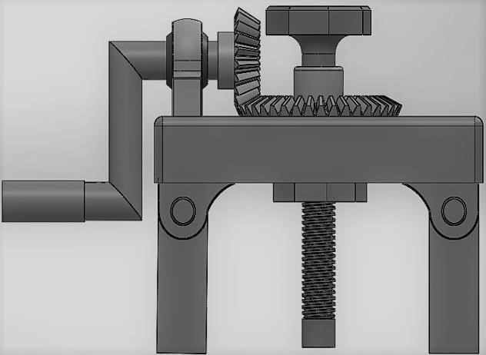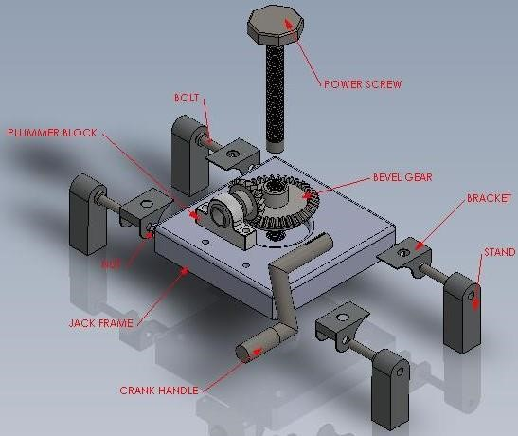

Figure 1: Side view of the jack. Figure 2: Exploded view of the jack.

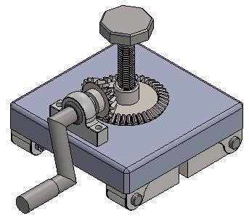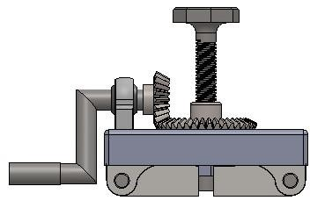

Figure 3: Pictorial view of the jack when folded.

**REFERENCES**

Benjamin, N. & Modestus, L. (2017). [Modified Screw Jack for Lifting Operation in Industrial Setting](https://www.researchgate.net/publication/322861067_Modified_Screw_Jack_for_Lifting_Operation_in_Industrial_Setting?enrichId=rgreq-b8f504d315ca69dcaf738363a2bf5682-XXX&enrichSource=Y292ZXJQYWdlOzMyMjg2MTA2NztBUzo1ODkyMjIwMTI1MjI1MDFAMTUxNzQ5Mjg4MzQxNA%3D%3D&el=1_x_3&_esc=publicationCoverPdf). *International Journal of Engineering and Technologies*, (13), 39-50.

Okoronkwo, C. & Chaudhary, L. (2016). Design of a hand water pump using a quick-return crank mechanism, *African Journal of Science, Technology, Innovation and Development,* 8(3), 292-298.

Rout, R., Mounika, C. & Priyanka, H. (2014). Design and fabrication of motorized automated object lifting jack. *IOSR Journal of Engineering*. 04(05) 6-12.

Vanjar, S., Bhogate, J., Kadam, A., Kalvinde, A. & Mohite, A. (2021). Design and Fabrication of Bevel Gear Operated Screw Jack. *International Journal of Scientific Research and Development*, 8(11), 53-55.

Vishwa, U., Sriram, B., Gokulnath, V., Naveen, M. & Tharanitharan, G. (2023). Design and Fabrication of Quick lifting jack with bevel gear arrangement using design thinking approach. *International Research Journal of Modernization in Engineering Technology and Science*, 5(2), 90-92.